Jenkins Task-01

- Install Jenkins and run Jenkins on port number 8081
>> Launch 1 EC2 Instance
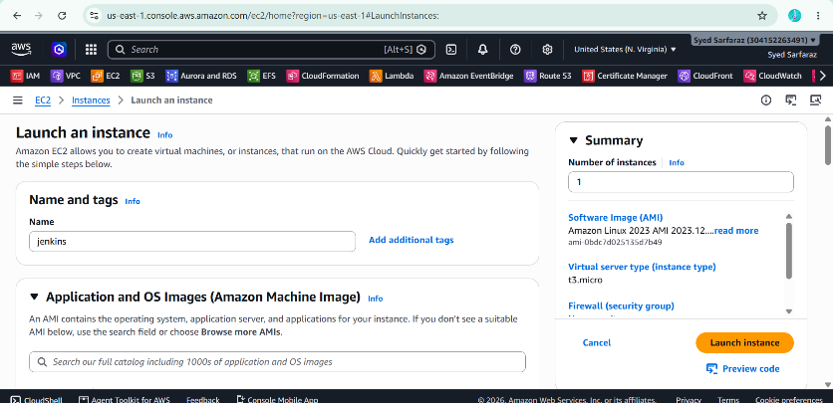
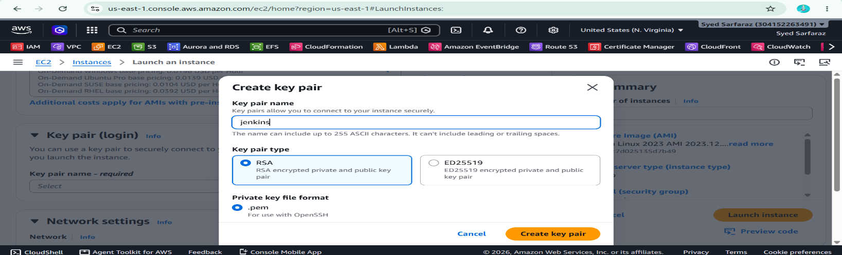

1. Connect to your EC2 instance
SSH into your Jenkins server:
ssh -i your-key.pem ec2-user@<PUBLIC-IP>

2. Update the system
sudo dnf update -y

3. Install Java
Jenkins requires Java. Install Java 21:
sudo dnf install java-21-amazon-corretto -y
Verify:
java -version
You should see something similar to:
openjdk version "21..."

4. Add the Jenkins repository
Import the Jenkins repository key:
sudo rpm --import https://pkg.jenkins.io/redhat-stable/jenkins.io-2026.key
Create the Jenkins repository:
sudo wget -O /etc/yum.repos.d/jenkins.repo https://pkg.jenkins.io/redhat-stable/jenkins.repo
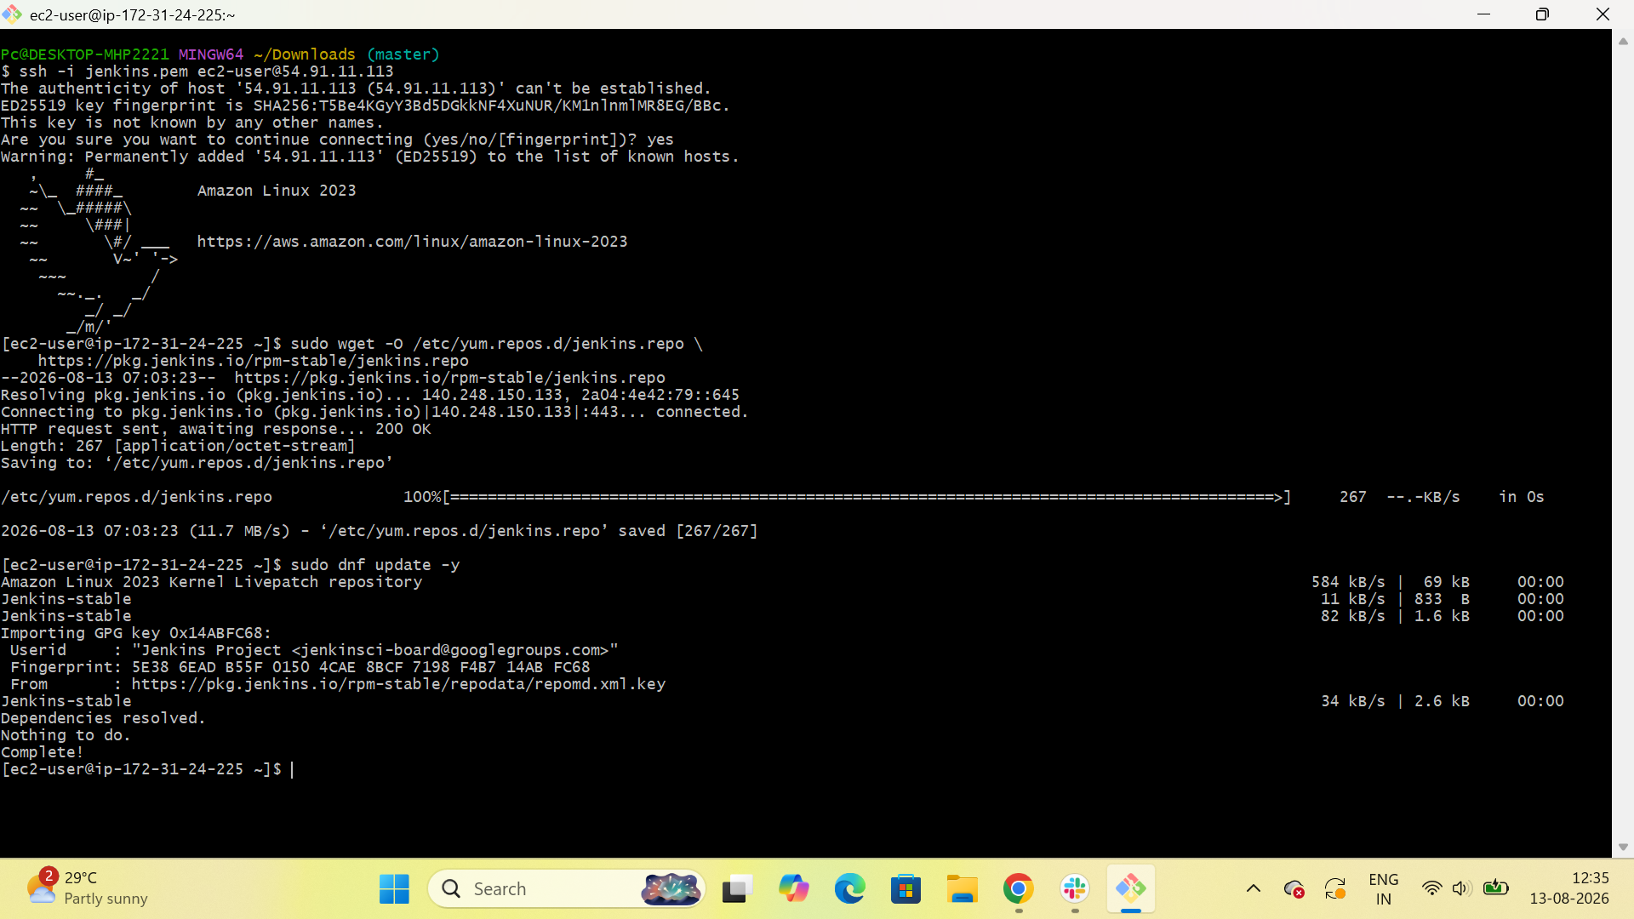

5. Install Jenkins
sudo dnf install jenkins -y
Verify Jenkins was installed:
jenkins --version
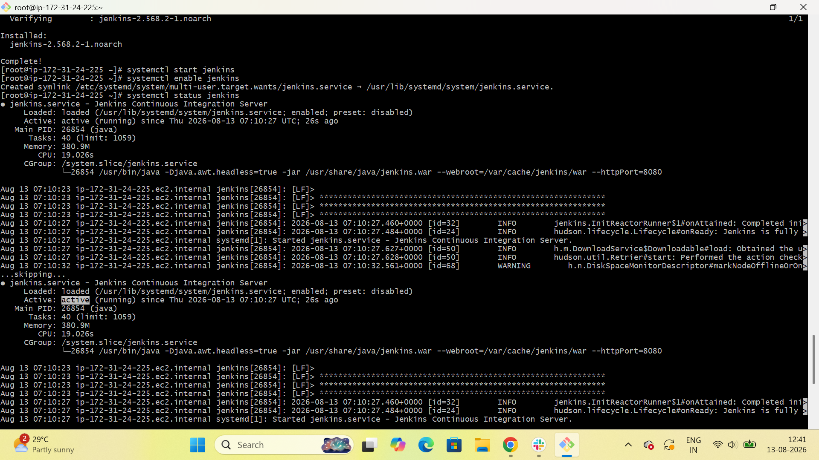

6. Configure Jenkins to use port 8081
Open the Jenkins configuration file:
sudo vi /etc/sysconfig/jenkins
Find:
JENKINS_PORT=8080
Change it to:
JENKINS_PORT=8081
Save and exit:
Press Esc → type :wq → press Enter
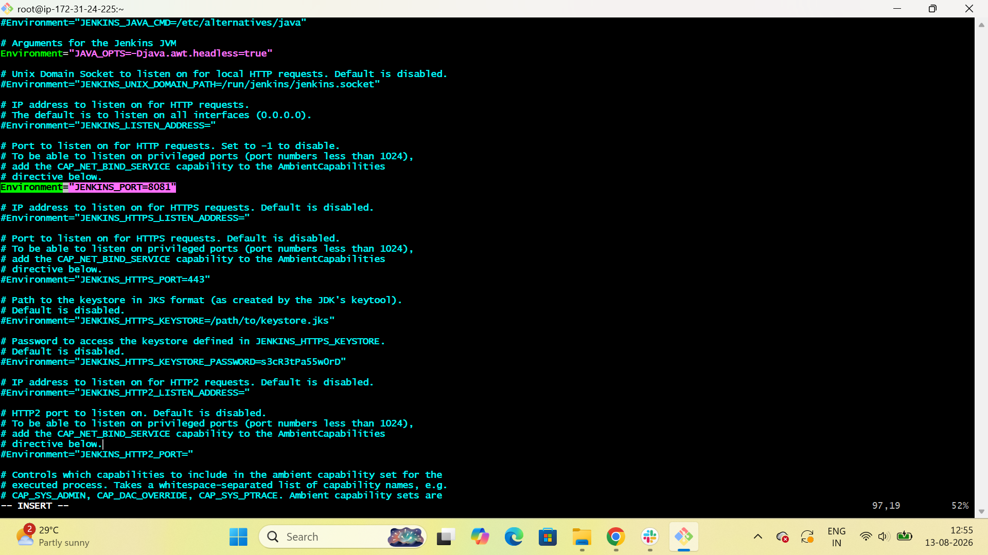
7. Start Jenkins
$ sudo systemctl start Jenkins
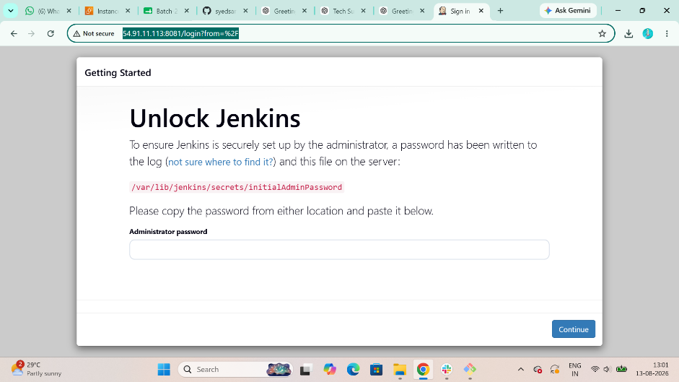

- Secure Jenkins server
Step:1 Connect to Jenkins GUL
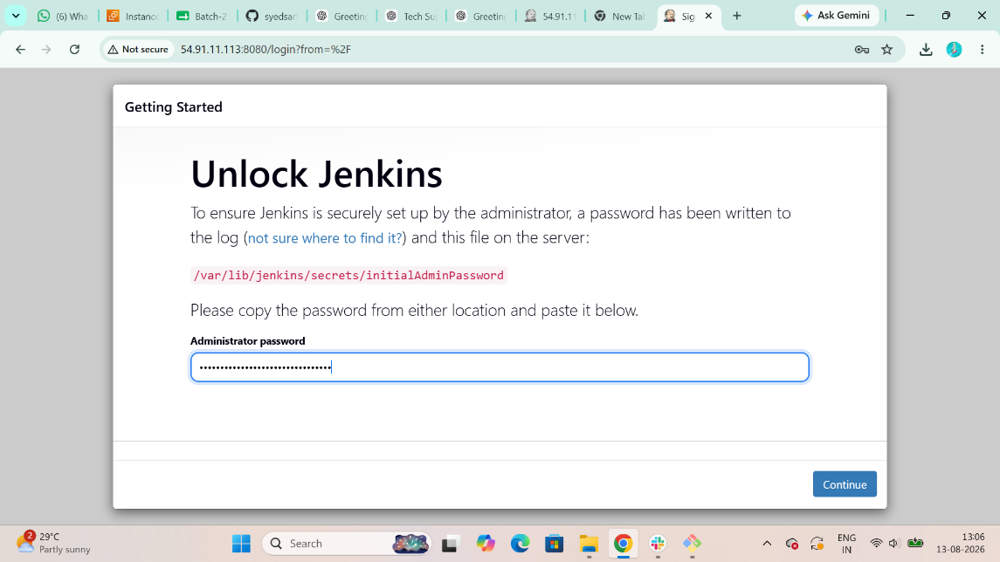
Step 2: Change the Default Username and Password
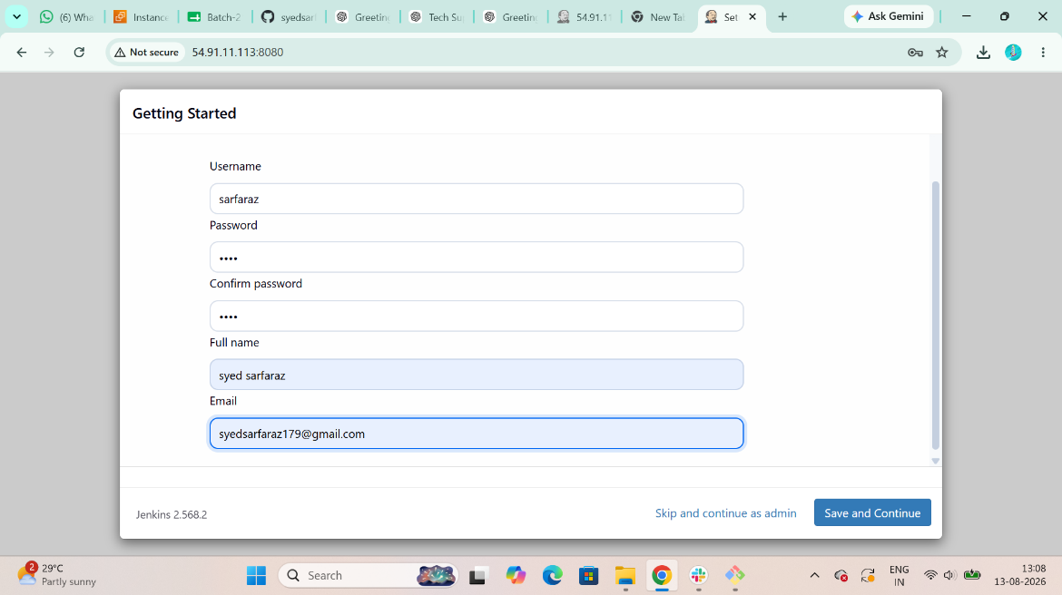

- Create users called DevOps, Testing in Jenkins with Limited access.

1. Create the DevOps user
Go to:
Jenkins Dashboard → Manage Jenkins → Users
Click:
Create User
Enter:
Username: DevOps
Password: <strong-password>
Confirm password: <strong-password>
Full name: DevOps
Email: <your-email>
Click:
Create User
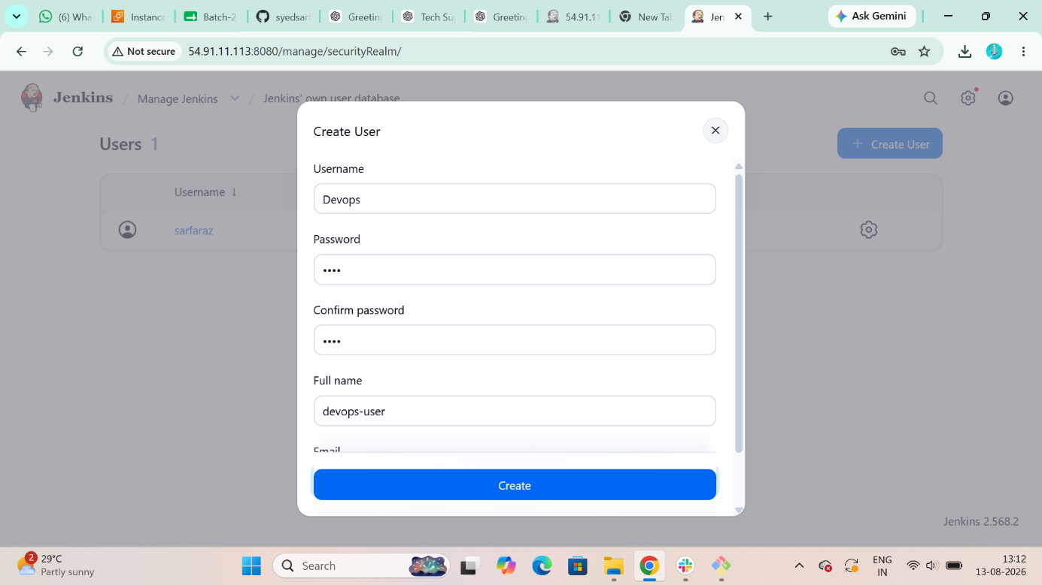

2. Create the Testing user
Go to:
Manage Jenkins → Users → Create User
Enter:
Username: Testing
Password: <strong-password>
Confirm password: <strong-password>
Full name: Testing
Email: <your-email>
Click:

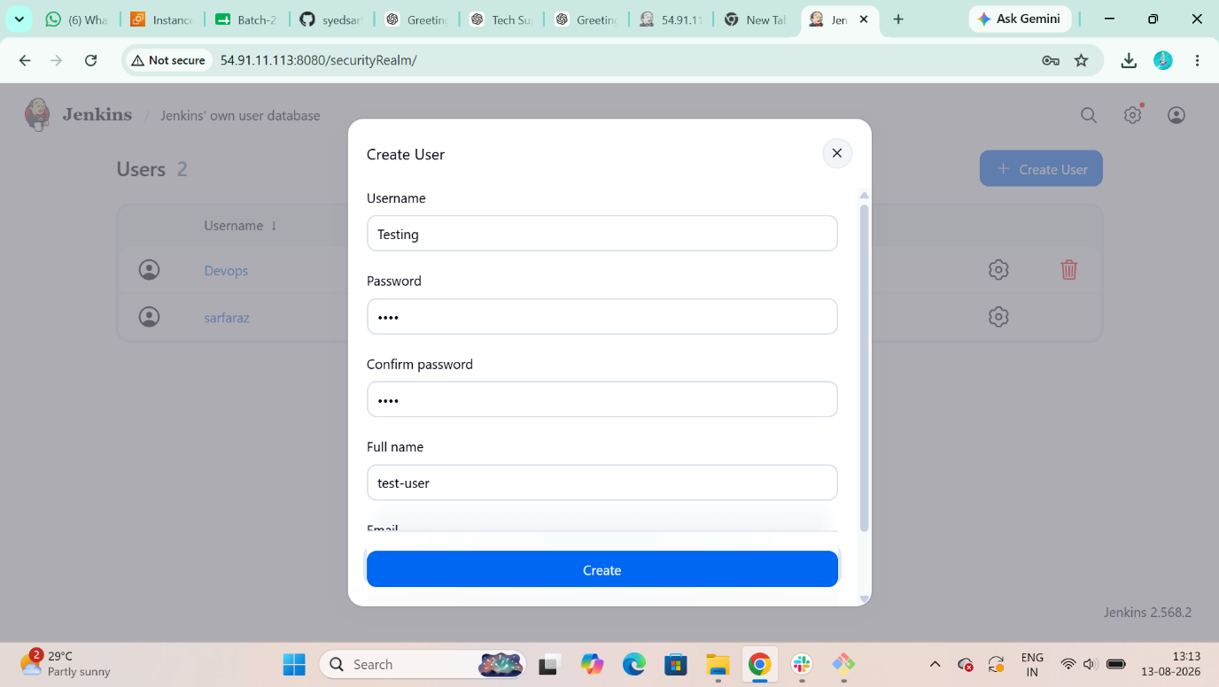

Now you have:
Admin:- Sarfaraz
DevOps
Testing
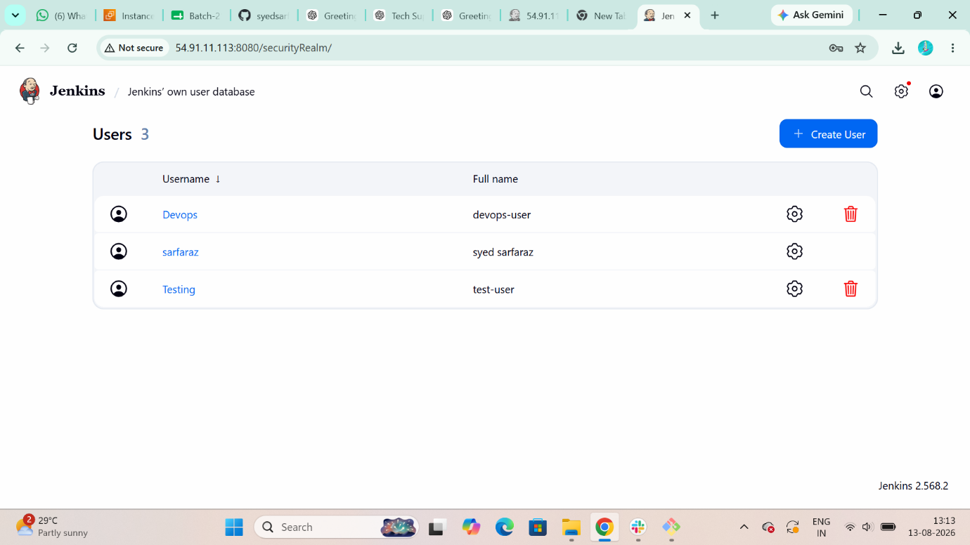
4. Give limited permissions
Go to:
Manage Jenkins → Security
Under Authorization, select:
Over all Read Only
You should see a permissions Read only
Add DevOps
Click:
Add user or group
Enter:
DevOps
Select the DevOps user.
Give only the required permissions.
For a basic DevOps user, give:
Overall → Read ✓
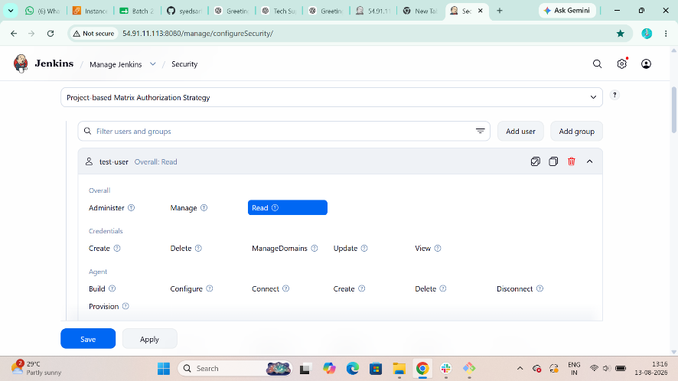

4. Give limited permissions
Go to:
Manage Jenkins → Security
Under Authorization, select:
Over all Read Only
You should see a permissions Read only
Add Testing
Click:
Add user or group
Enter:
Testing
Select the Testing user.
Give only the required permissions.
For a basic Testing user, give:
Overall → Read ✓
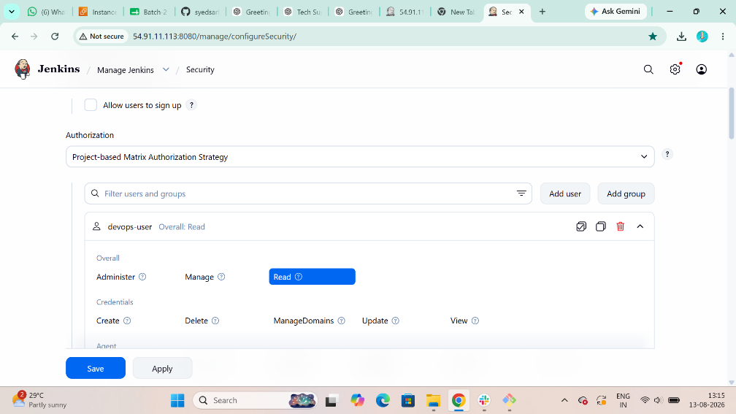

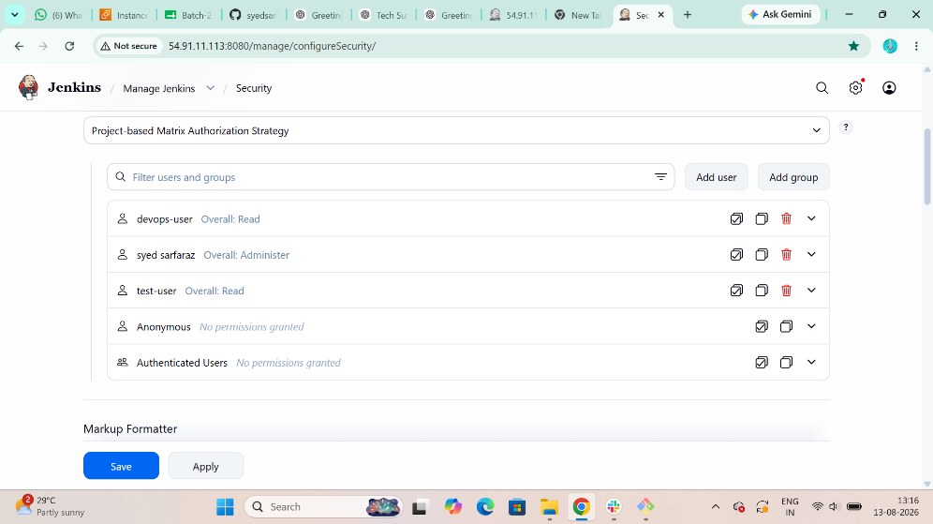

- Configure labels and restrict the jobs to execute based on label only.
Step 1: First Install NODE AND LABEL PARAMETER Plugins for Restriction
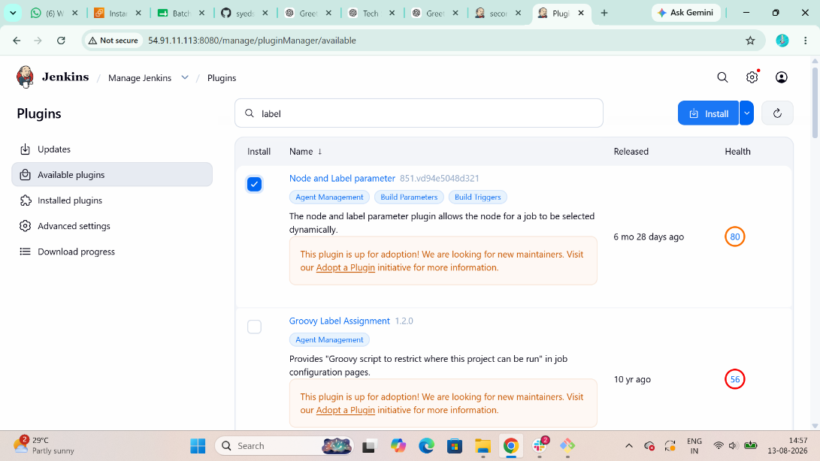

Step 2: Then Create a First Job and name the Job and Select Freestyle Project
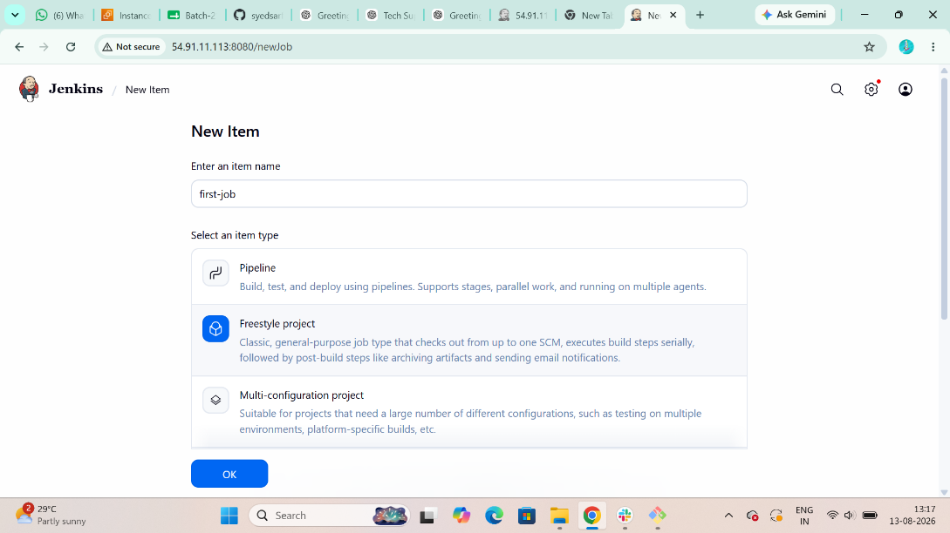
Step 3: Then Open your job and write a command
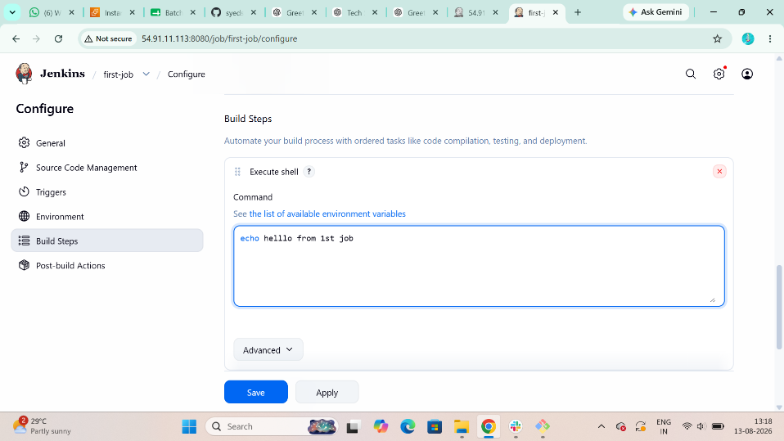
Step 4: Add Disk Space Monitoring Thresholds
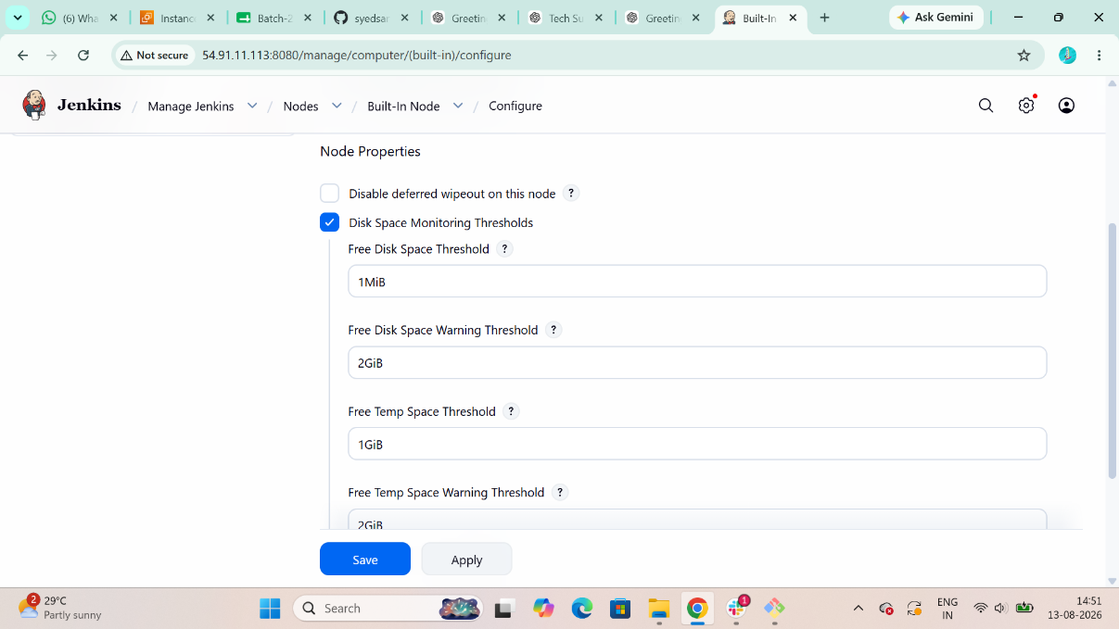

Step 5: Create a Second Job and name the Job and Select Freestyle Project
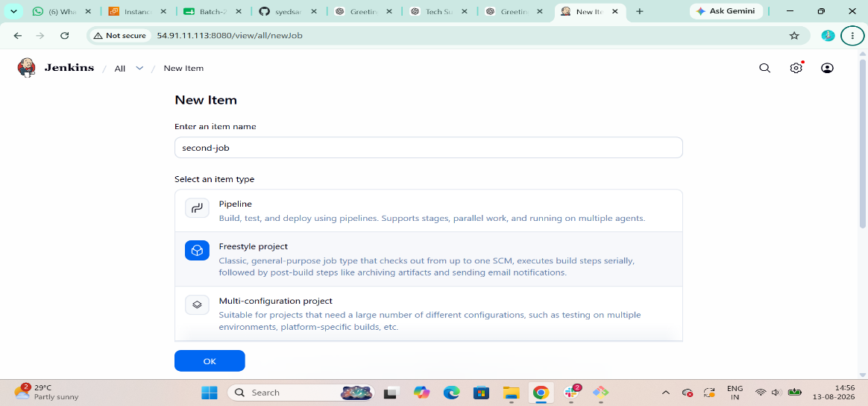
Step 6: Add Label to restrict the jobs In my case my I am adding java Label
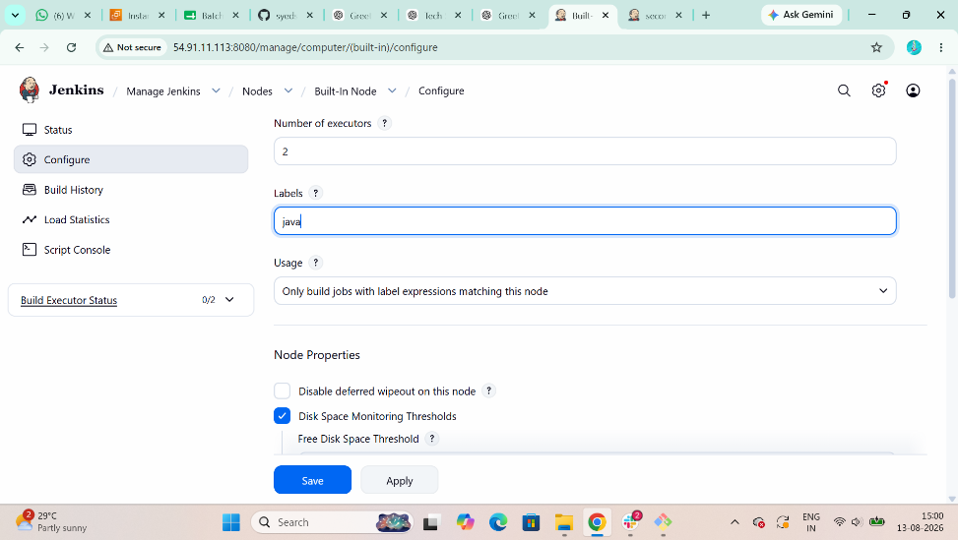
Step 6: The Result of Two Job’s
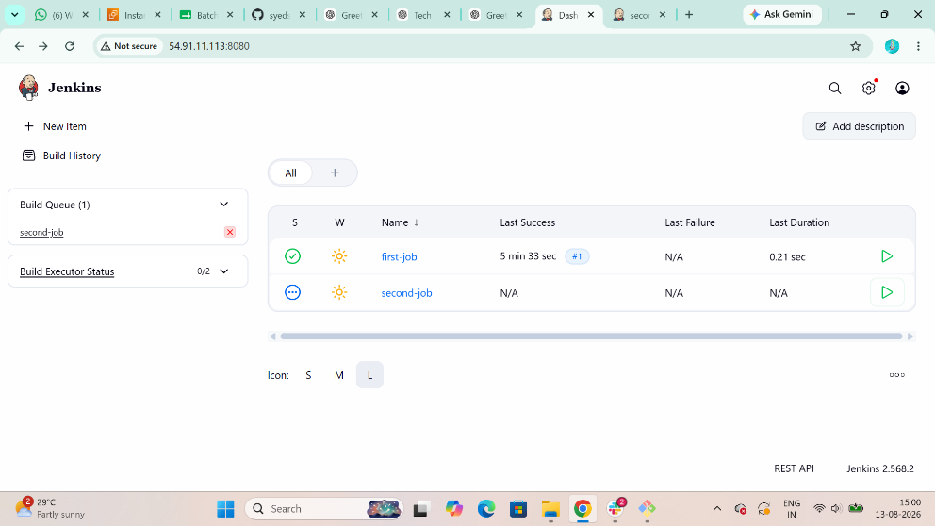

5. Create Three sample jobs using the below URL.
Source Code:https://github.com/betawins/Techie_horizon_Login_app.git
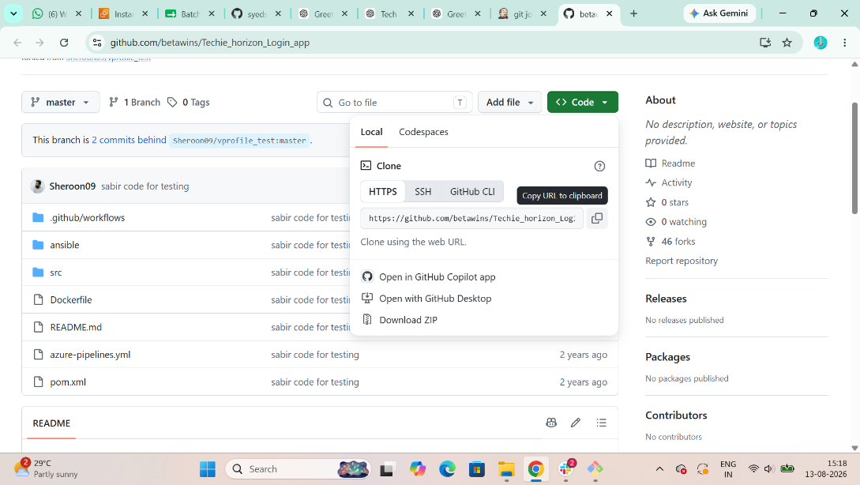

Step 1: Create 1st Job give Name and Select Freestyle Project
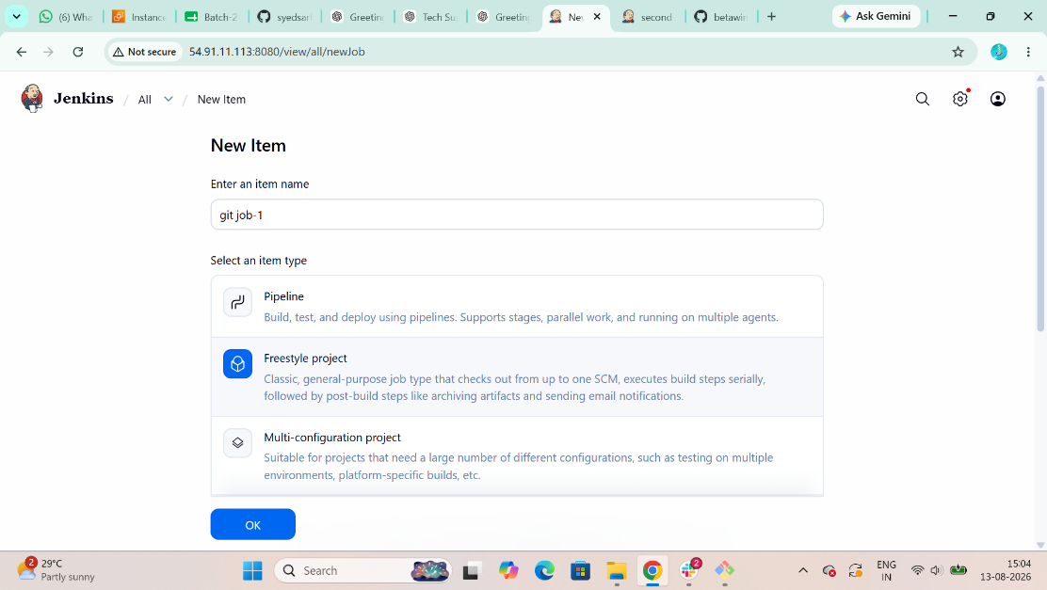

Step 2: In SCM Git Add Your Repository <URL> That you want to use
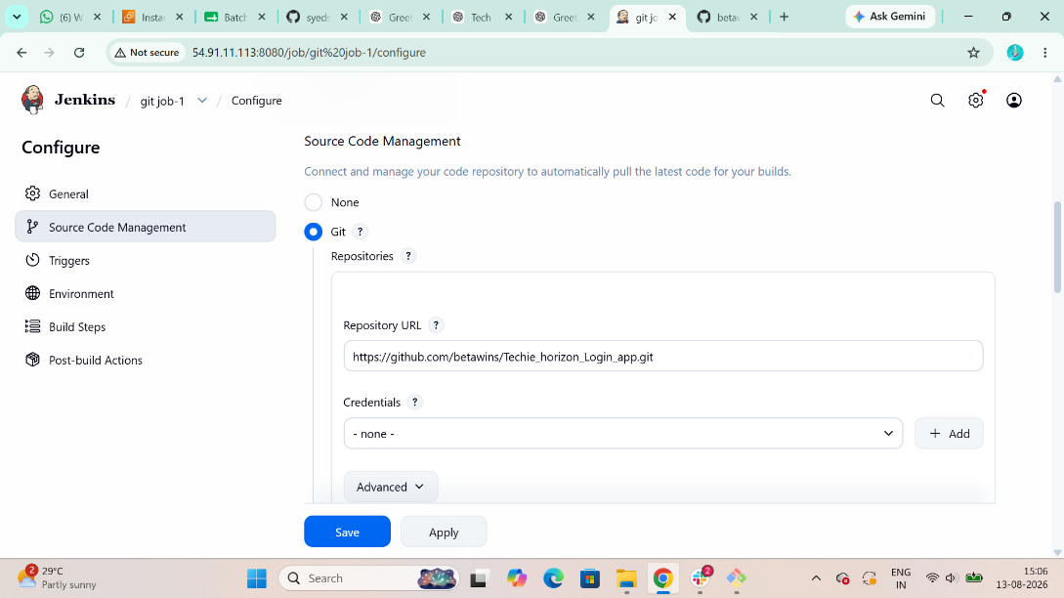
Step 3: Then Create it
Step 4: After Creating go to Jenkins server and run this command and you can see your Sample job’s
$ cd /var/lib/Jenkins/workspace
$ ls
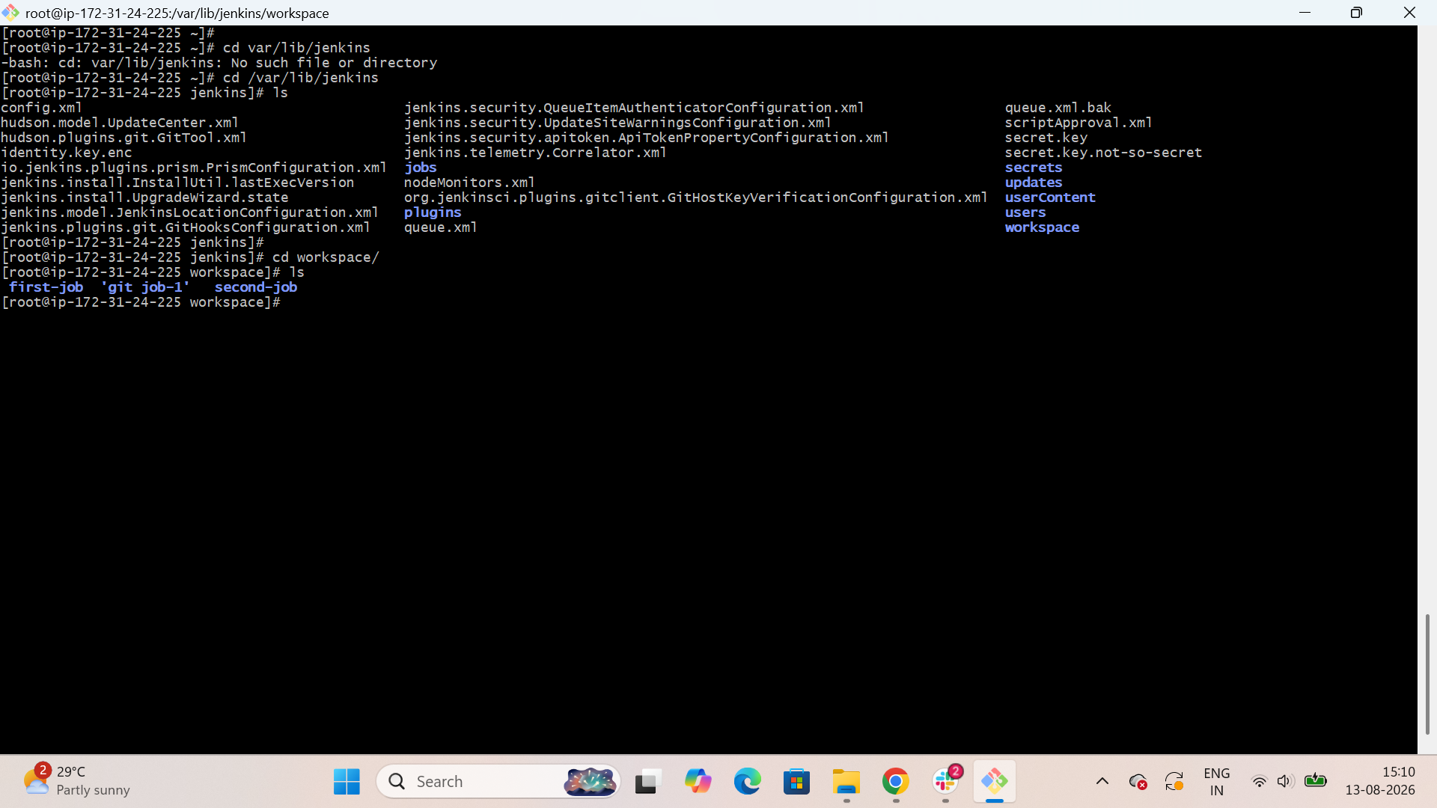

Step 5: Create 2nd Job give Name and Select Freestyle Project
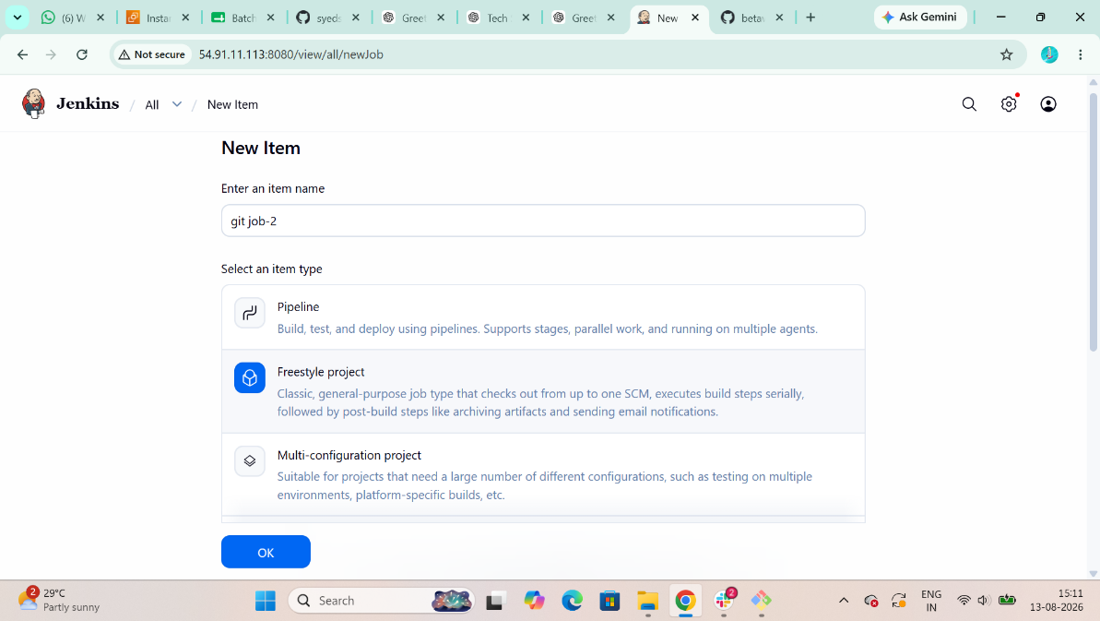
Step 6: Add SCM Repo <url> Then Build it
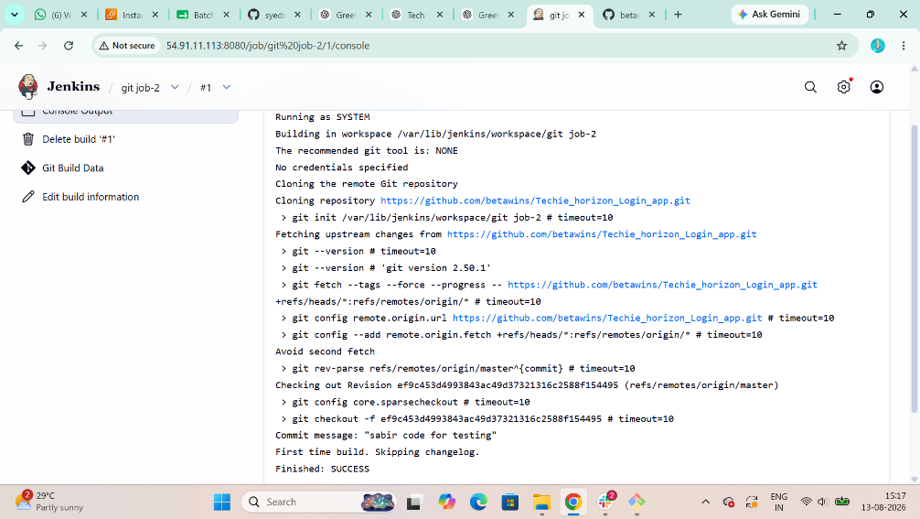

Step 7: Create 3rd Job give Name and Select Freestyle Project
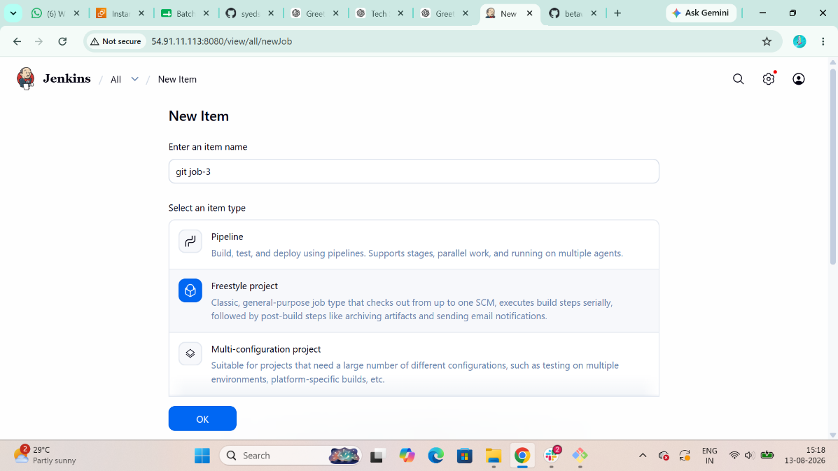

Step 8: Add SCM Repo <url> Then Build it and Then Create it
Result of Three sample jobs using the Repo URL
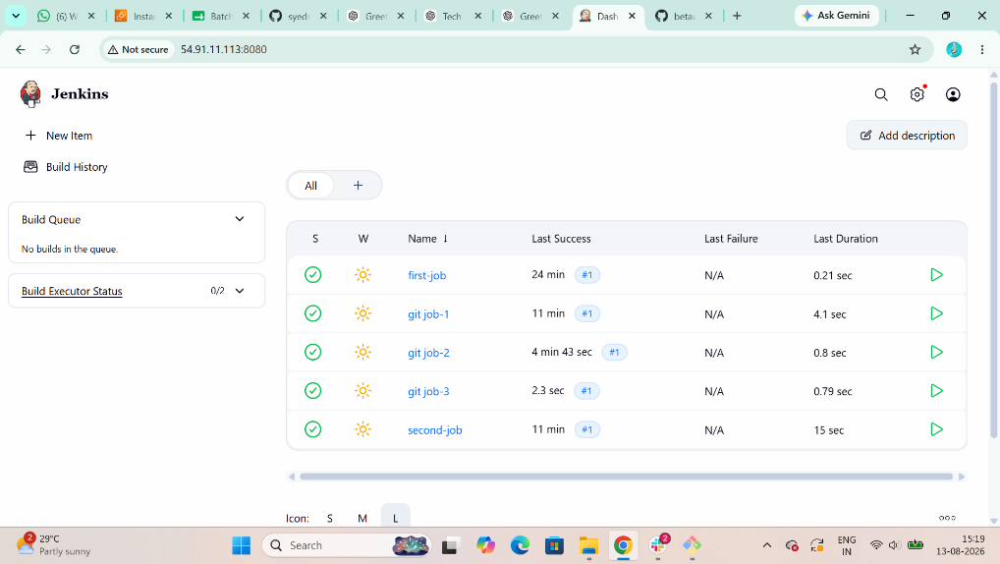
In Jenkins Server run this command to get all the jobs
$ cd /var/lib/Jenkins/workspace
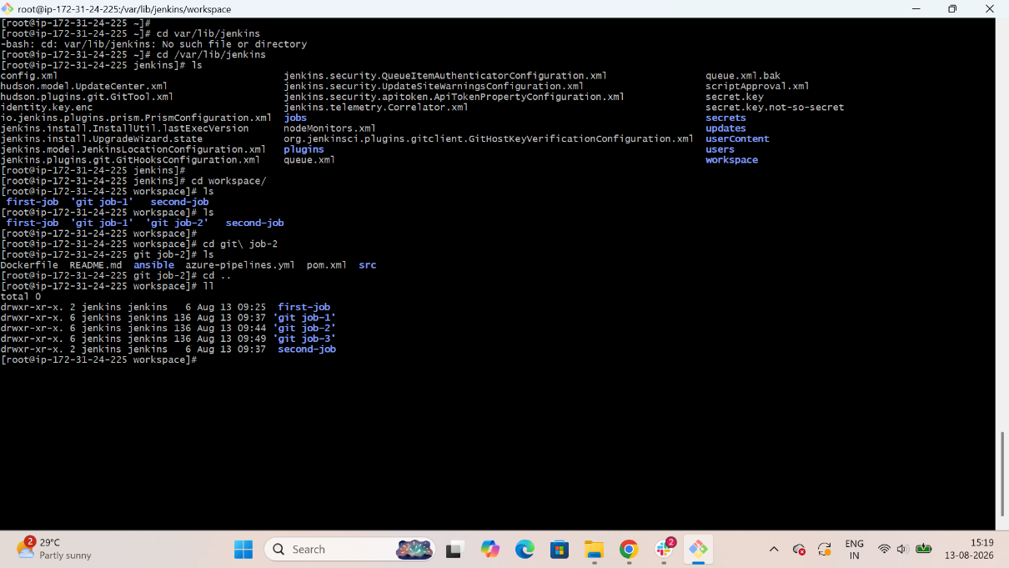

6. Create one Jenkins job using GitHub Private repository.
Step 1: First Convert Your Repository into Private if it is Public
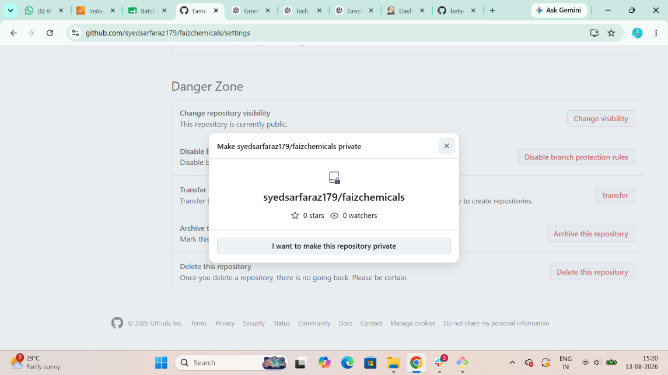
Step 2: Create a GitHub Personal Access Token
Because the repository is private, Jenkins needs authentication.
In GitHub:
Profile → Settings → Developer settings → Personal access tokens → Tokens (classic)
Click:
Generate new token → Generate new token (classic)
Give it a name, for example:
Jenkins
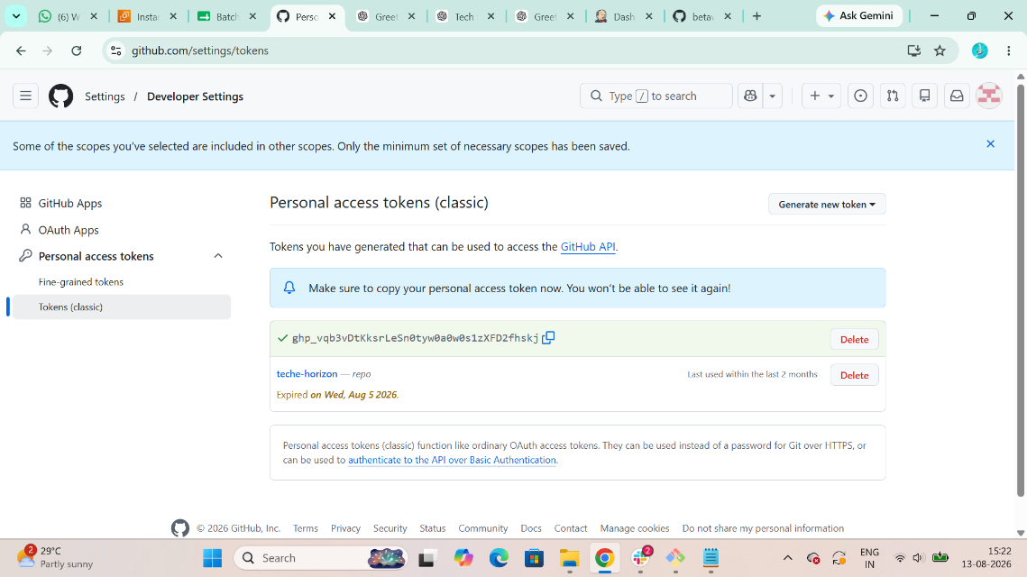

Step 3: Then Install Git Server Plugins to Create Jenkins job using GitHub Private repository
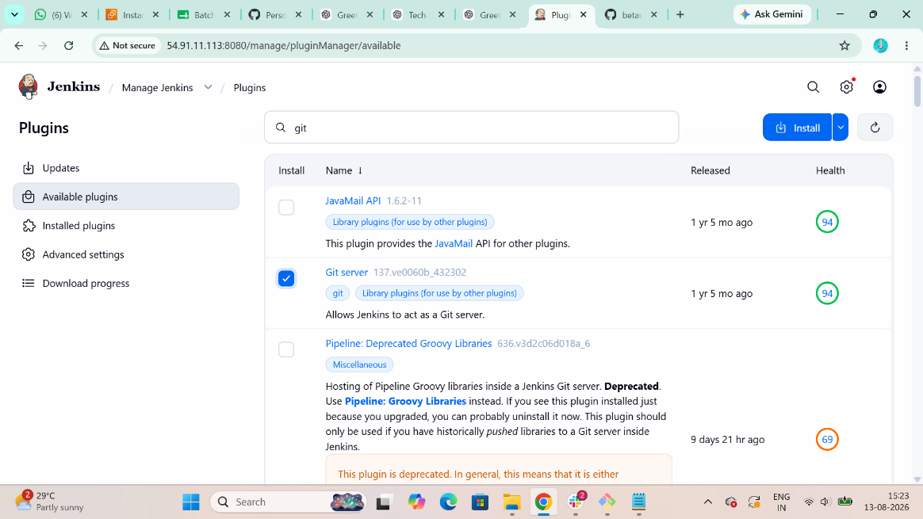

Step 4: Add GitHub credentials to Jenkins
Go to:
Jenkins Dashboard → Manage Jenkins → Credentials
Select:
System → Global credentials (unrestricted)
Click:
Add Credentials
Set:
Field | Value
Kind | Username with password
Username | Your GitHub username
Password | GitHub Personal Access Token
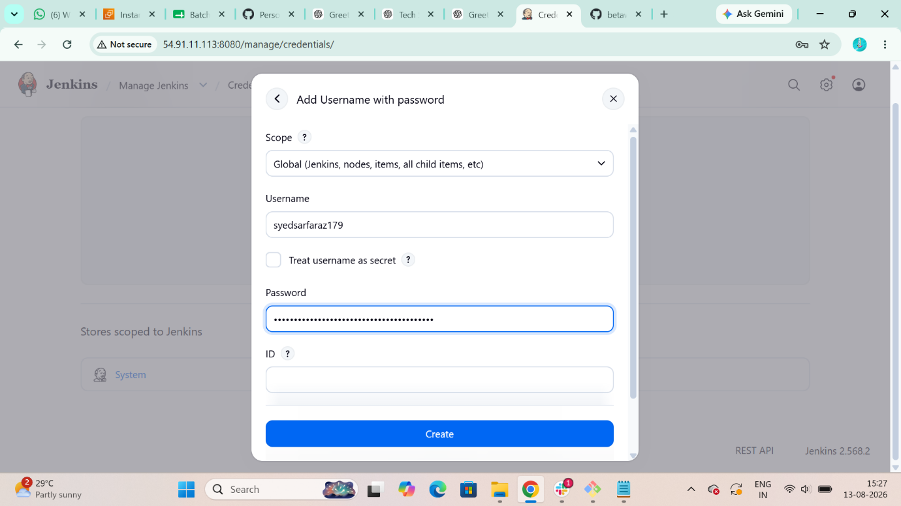
Step 5: Add github-private-repo <url>
Click: Create
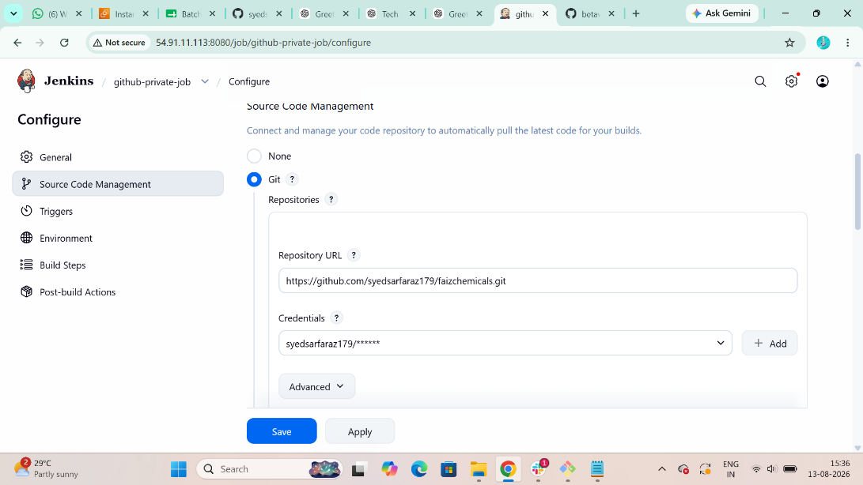
Step 6: Verify the console output
Open:
Build History → #1 → Console Output
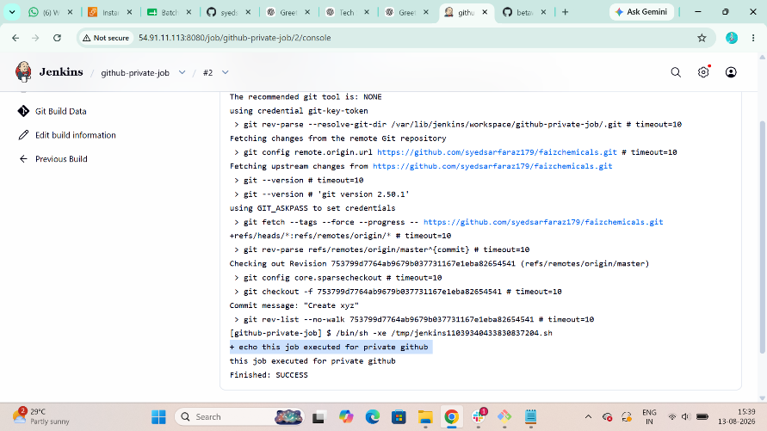
Over All Results Of Jenkins Jobs
